
REPORT
ON
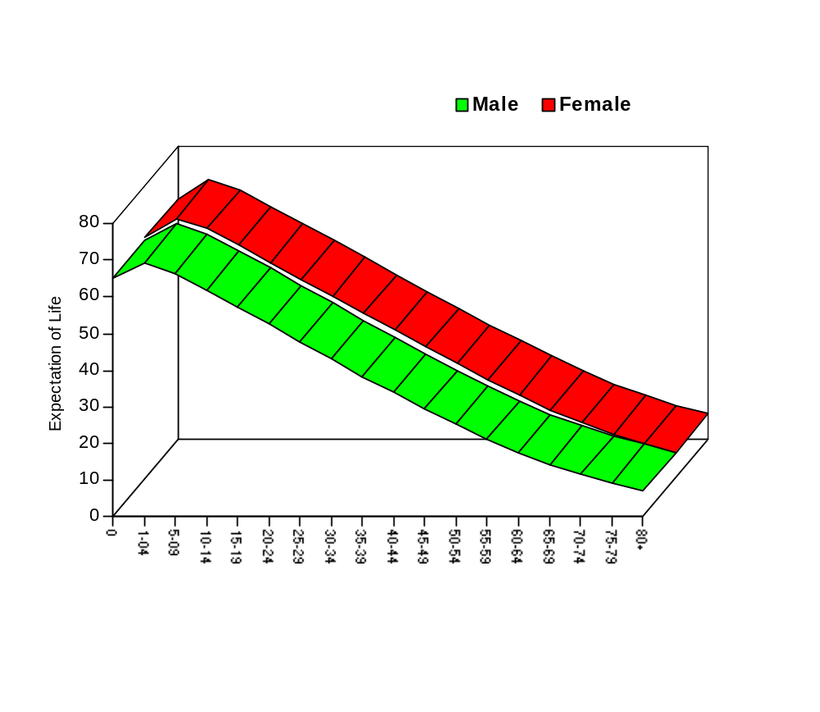SAMPLE VITAL REGISTRATION SYSTEM, 2004

DECEMBER, 2006

evsjv‡`k cwimsL¨vb ey¨‡iv
BANGLADESH BUREAU OF STATISTICS
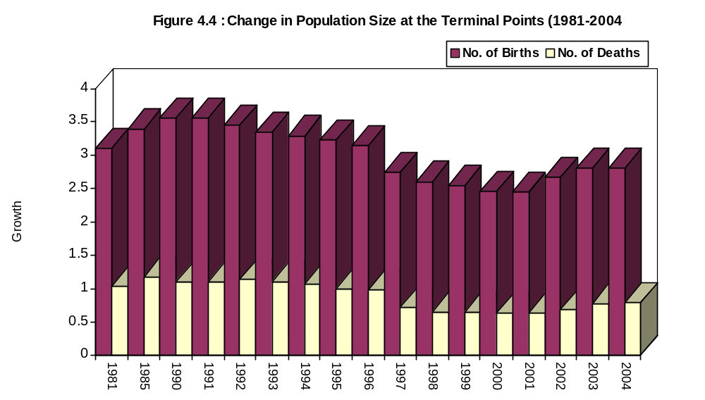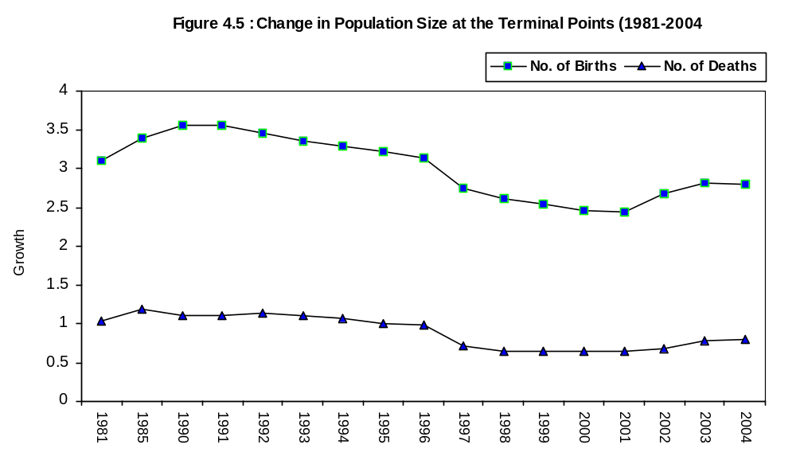

24

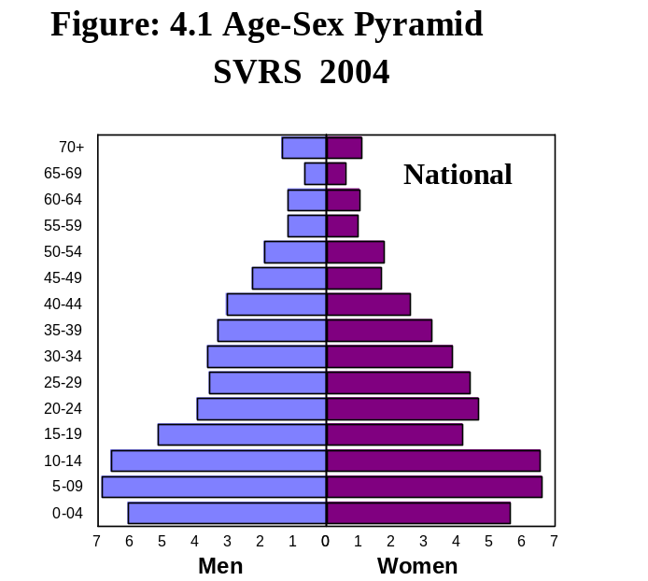 | 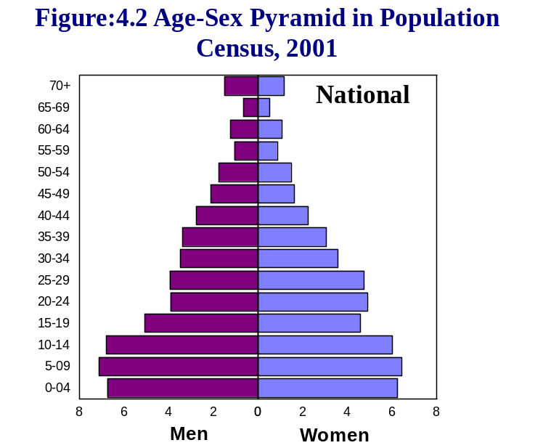
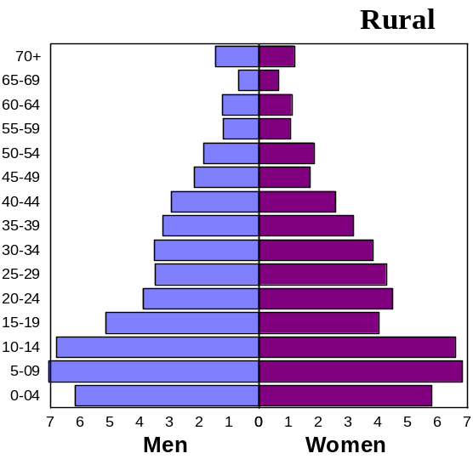 | 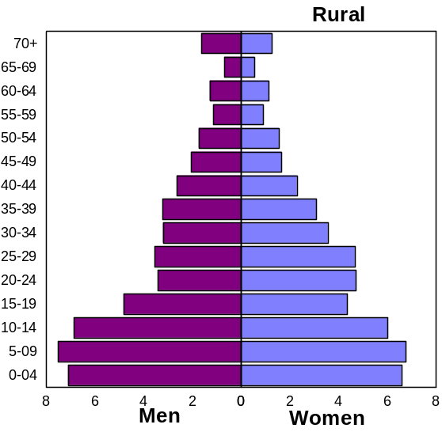
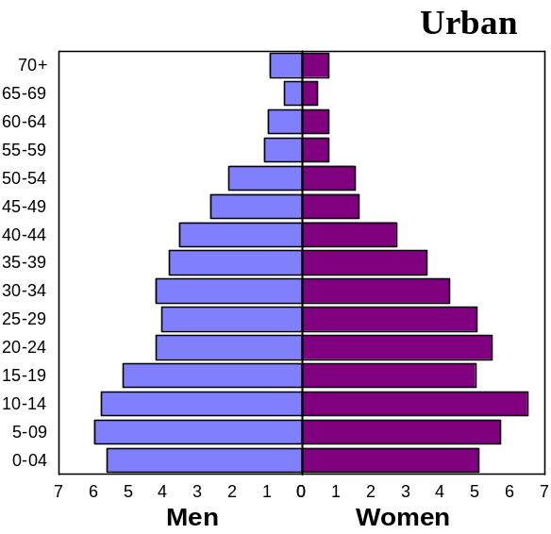 | 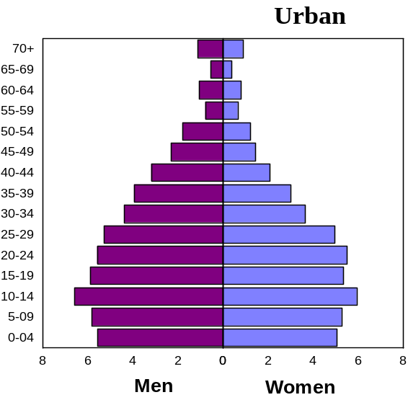

29

Chapter-5
Fertility
Fertility refers to the role of birth in population change and human reproduction. Patterns, levels and trends of fertility in Bangladesh are therefore, urgently needed for formulation and successful implementation of population control and health programme. Data on births was collected with birth card (Schedule-3). With this schedule data on population, mothers line number, sex, date of birth, registration status, date of registration, place of birth, type of birth, live births, survival status, mother’s name, mothers age, mothers education and total live birth were collected by the dual recording system. In this report estimated number of births, crude birth rate, age specific fertility rate, total fertility rate, total marital fertility rate, general fertility rate, gross reproduction rate and net reproduction rate have been incorporated.

5.1 Crude Birth Rate
Crude birth rate (CBR) per 1000 populations for 1981-2004 presented in Table 5.1 It shows the trends of CBR over time 1981-2004.
T5.1 Crude Birth Rate per 1000 Population by Locality 1981-2004
Year | National | Rural | Urban
1981 | 34.6 | 35.7 | 24.8
1982 | 34.8 | 36.9 | 22.9
1983 | 35.0 | 36.4 | 27.1
1984 | 34.8 | 36.1 | 25.0
1985 | 34.6 | 35.3 | 28.0
1986 | 34.4 | 35.4 | 25.9
1987 | 33.3 | 34.6 | 24.8
1988 | 33.2 | 34.6 | 24.9
1989 | 33.0 | 34.5 | 24.4
1990 | 32.8 | 34.3 | 24.6
1991 | 31.6 | 32.9 | 23.9
1992 | 30.8 | 32.2 | 23.7
1993 | 28.8 | 30.0 | 21.0
1994 | 27.0 | 29.1 | 20.2
1995 | 26.5 | 28.5 | 19.4
1996 | 25.6 | 27.8 | 19.0
1997 | 21.0 | 24.5 | 16.2
1998 | 19.9 | 21.0 | 14.0
1999 | 19.2 | 20.9 | 13.8
2000 | 19.0 | 20.8 | 13.7
2001 | 18.9 | 20.7 | 13.6
2002 | 20.1 | 21.0 | 16.6
2003 | 20.9 | 21.7 | 17.9
2004 | 20.8 | 21.6 | 17.8
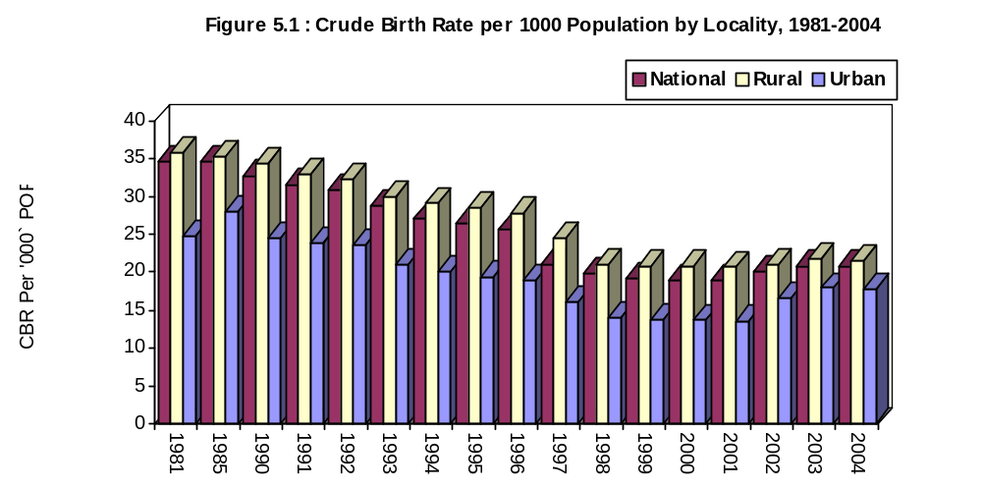

It revealed from the table that the crude birth rate was 34.6 in 1981, 33.3 in 1987 and 20.8 in 2004. In rural areas these rates were 35.7, 34.6 and 21.6 respectively. In urban areas these rate were 24.8, 24.8 and 17.8 respectively.
37
82

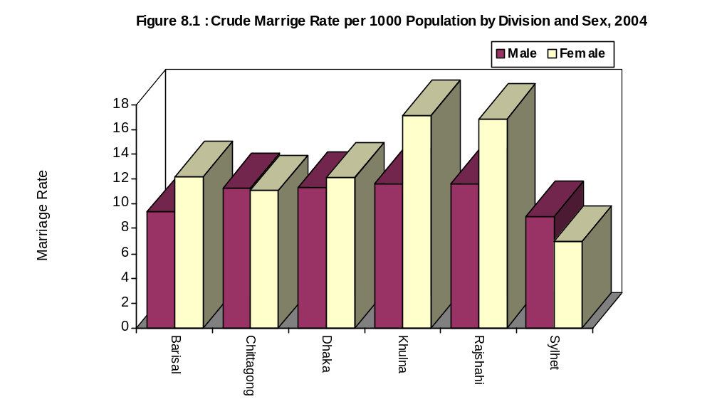
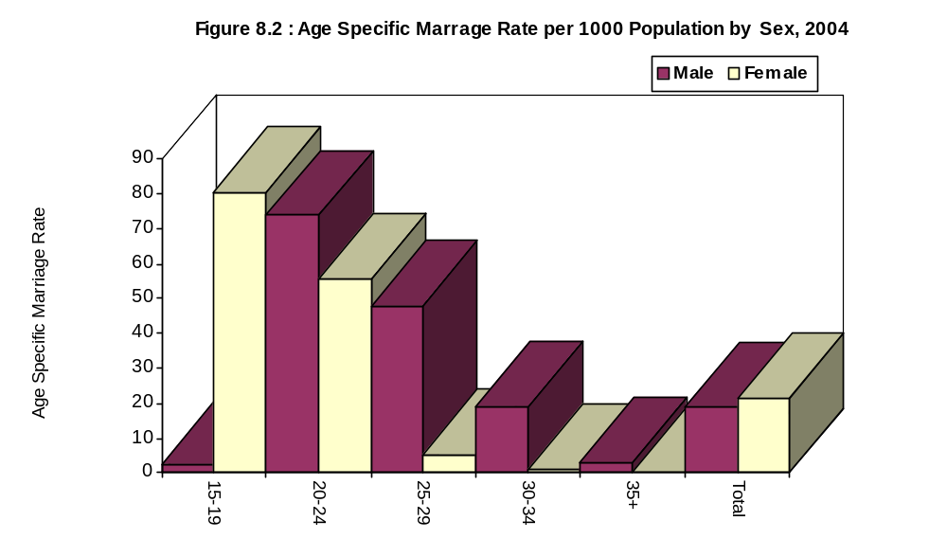
It is apparent from the table that ASMR for male was the highest (73.94) at the age group 20-24 and was the lowest (3.00) at the age-group 35+. In case of female it was the highest (80.40) at the age-group 15.19 and was the lowest (0.31) at the age-group (35+). In case of rural area ASMR for male was the highest at the age-group 20-24 (84.19) and was the lowest at the age-group 35+ (3.19) but in case of female it was the highest at the age-group 15-19 (92.00) and was the lowest in the age group 35+ (0.35). In case of urban area ASMR for male was the highest for the age group 20-24 (32.97) and was the lowest for the age group 35+ (2.22). ASMR for female was also the highest at the age group 15-19(38.88) and was the lowest in the age group 35+ (0.13).

87

T8.12 Age Specific Divorce Rate by Age and Sex, 2004
Age-group | Both Sexes | Male | Female
15-19 | 2.07 | 0.28 | 4.13
20-24 | 2.41 | 1.00 | 3.61
25-29 | 1.25 | 1.07 | 1.40
30-34 | 0.63 | 0.60 | 0.65
35+ | 0.16 | 0.13 | 0.19
Total | 0.83 | 0.36 | 1.32
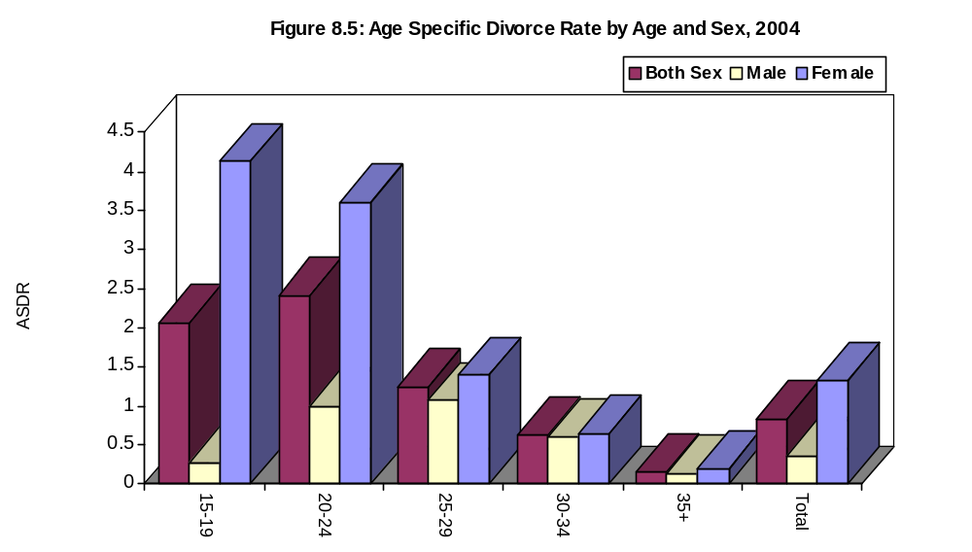

It is apparent from the tables that age specific divorce rate for female was the highest (4.05) at the age group 15-19 which was followed by 3.37 at the age group 20-24. For male it was the highest (0.98) at the age group 20-24 which was followed by 1.07 at the age group 25-29. The divorce rate for male was only a 0.13 at the age group 35+.

8.7.3 Age-Specific Separation Rate
Age specific separation rate has been calculated as the relative number of separation at a defined age group per 1000 population of that age group. Age specific separation rate as obtained in 2004 is shown at the table DS05 and T8.13.

95

T8.13 Age Specific Separation Rate by Age group and Sex, 2004
Age-group | Both Sexes | Male | Female
15-19 | 0.57 | 0.33 | 0.85
20-24 | 1.15 | 0.87 | 1.39
25-29 | 0.63 | 0.58 | 0.67
30-34 | 0.44 | 0.47 | 0.42
35+ | 0.16 | 0.14 | 0.17
Total | 0.91 | 0.71 | 1.12
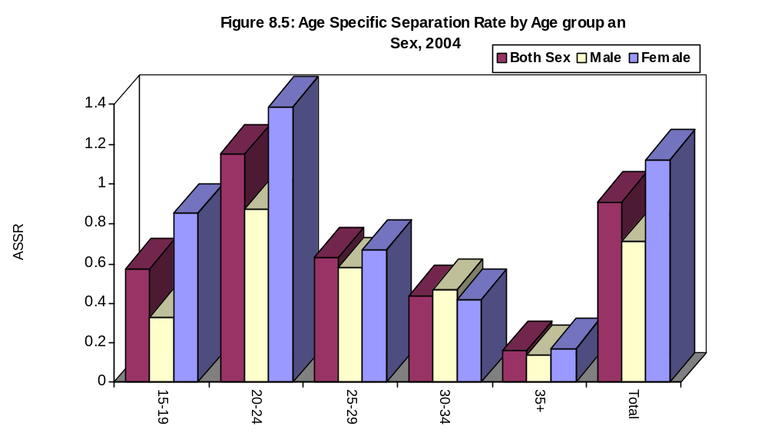
It is apparent from the table that age-specific separation rate for female was the highest (1.29) at the age group 20-24 followed by the age-group 15-19 (0.83). For male it was the highest (0.86) at the age group 20-24 followed by the age group 25.29 (0.57). There were least separation at the age group 35+ for both the males (0.14) and females (0.17).

8.7.4 Reasons for Divorce
Reasons for divorce as evidence from SVRS 2004 is shown at table DS06. It is apparent from the table that for male the main reasons for divorce were - Failure in conjugal life, characterless, dowry, inability in maintaining expenditure, child marriage. In case of female the main reasons for divorce were – inability in maintaining expenditure, physical tortures, re-marriage, dowry, failure in conjugal life, characterless, impotent. The table also shows the reasons for divorces for males and females in urban and rural areas.
8.7.5 Reasons for Separation
Reasons for separation are shown at table DS07. It is apparent from the table that for male the principal reason for separation were inability in maintaining expenditure failure in conjugal life, remarriage, dowry, missing child marriage. In case of female the principal reasons for separation were inability in maintaining expenditure, remarriage, physical torture, dowry characterless and failure in conjugal life. Urban-rural differentials can also be seen in the table DS07.
96

9.6 Locality wise Differentials of CPR
Urban-rural differentials in CPR has been shown in table C03 and also in table T9.7. The table contains data on CPR of currently married women showing variations at urban and rural levels.
T9.7 Contraceptive Prevalence Rate by Method and Locality, 2003 and 2004
Method | 2003 |  |  | 2004
Method | National | Rural | Urban | National | Rural | Urban
Any Method | 55.13 | 52.17 | 60.37 | 56.19 | 53.37 | 60.79
Any Modern Method | 50.19 | 47.76 | 54.51 | 51.16 | 48.37 | 54.12
Condom | 5.32 | 4.08 | 7.52 | 5.58 | 4.26 | 7.56
Oral pill | 32.35 | 31.70 | 33.49 | 32.84 | 32.31 | 33.44
Injection | 9.96 | 9.43 | 10.89 | 10.12 | 9.07 | 10.16
Male sterilization | 0.21 | 0.22 | 0.20 | 0.20 | 0.21 | 0.18
Female sterilization | 1.84 | 1.84 | 1.84 | 1.78 | 1.78 | 1.79
IUD | 0.62 | 0.57 | 0.71 | 0.64 | 0.64 | 0.66
Traditional Method | 4.88 | 4.40 | 5.73 | 5.03 | 4.53 | 6.08
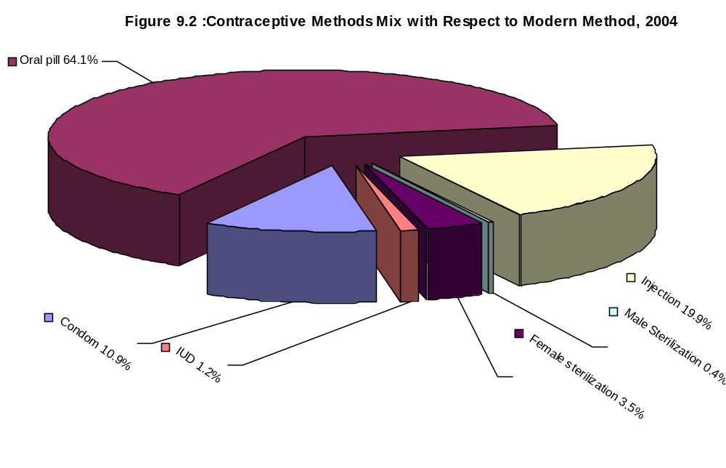It is apparent from the table that the overall rate of current use is higher in urban area than in rural areas. It was 60.79 percent among currently married women of urban areas as compared to 53.37 percent among women of rural areas.

102

